**Issue Log**

Log of issues to be resolved on the project. Issues are problems, gaps, inconsistencies or conflicts that occur unexpectedly during the lifecycle of a project. Issues can include problems with the staff or suppliers, technical failures, material shortages or any other problem that has a negative impact on the project.

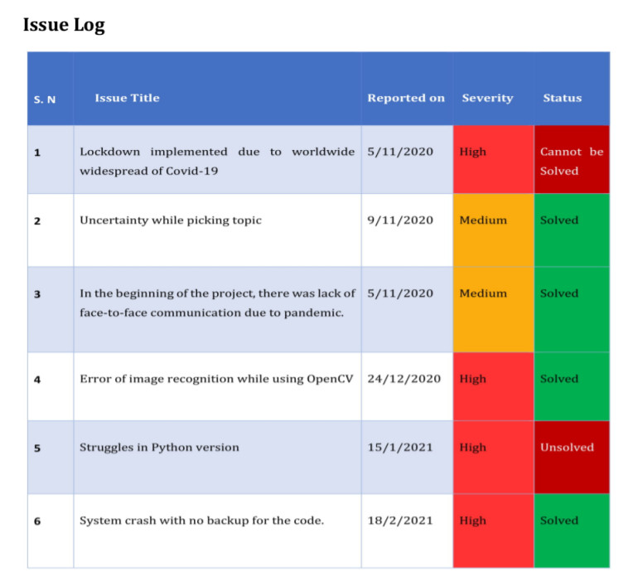

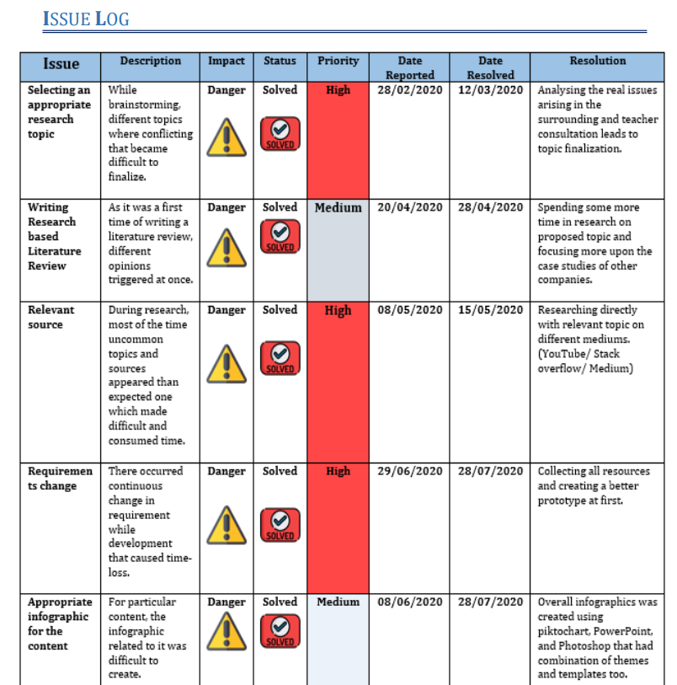

**Mind Map**

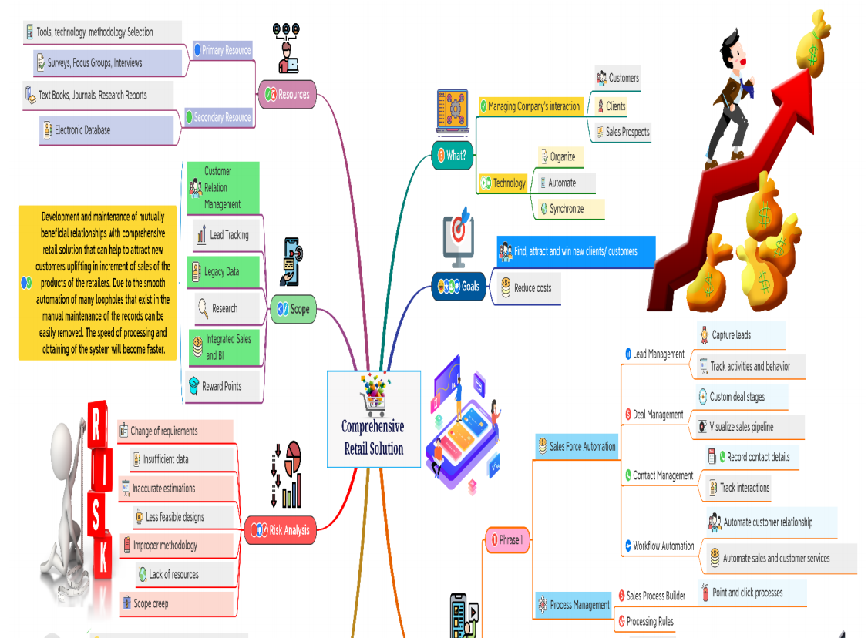

**Risk Analysis**

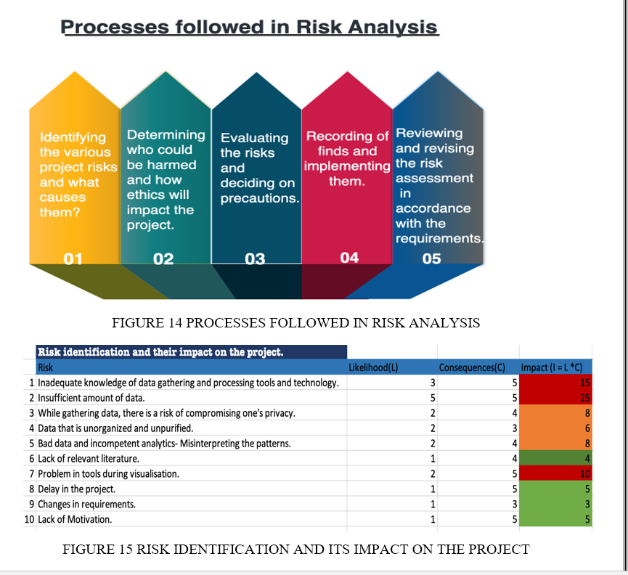

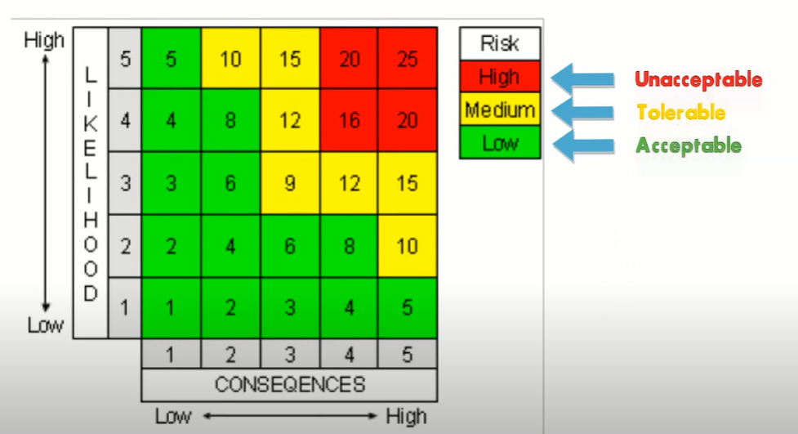

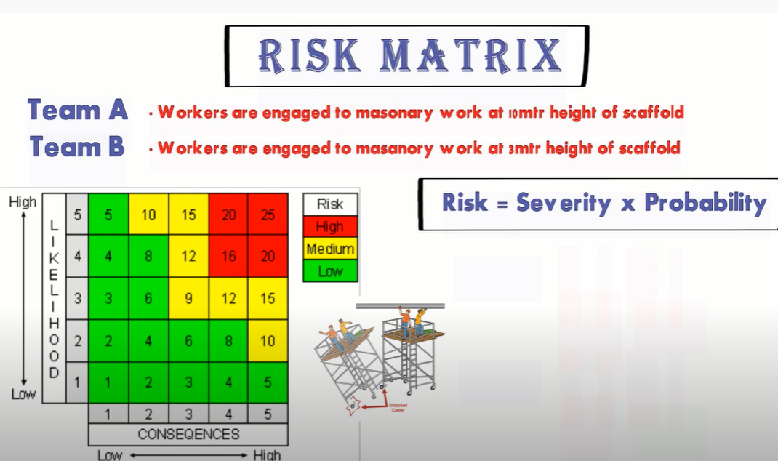

The key difference is an “**issue**” already has occurred and a “**risk**” is a potential issue that may or may not happen and can impact the project positively or negatively.

